**What is different between REST API and RESTful API?**

**REST**

 (Representation State Transfer) **API**:  It is basically an architectural style that makes productive use of existing technology and protocols of the web. It is a set of rules that developers need to follow when they develop their API or services that are scalable. It is used with HTTP protocol using its verbs such as GET, DELETE, POST, PUT.   
**RESTful API**:

It is simply referred to as web services executing such as architecture.

| **REST API** | **RESTful API** |
| --- | --- |
| REST is an architectural pattern used for creating web services. | RESTful API is used to implement that pattern. |
| The data format of REST is based on HTTP. | The data format of RESTful is based on JSON, HTTP, and Text. |
| Working of URL is based on request and response. | Working of RESTful is based on REST applications. |
| It is more user-friendly and highly adaptable to all business enterprises and IT. | It is too flexible. |
| It is required to develop APIs that allow interaction among clients and servers. | It simply follows REST infrastructure that provides interoperability among different systems on the whole network. |

**What are Web API filters?**

Filters are basically used to add extra logic at different levels of Web API framework request processing.  Different types of Web API filters are available as given below:

* **Authentication Filter:**
* It handles authentication and authenticates HTTP requests. It also helps to authenticate user detail. It checks the identity of the user.
* **Authorization Filter:**

 It handles authorization. It runs before controller action. This filter is used to check whether or not a user is authenticated. If the user is not authenticated, then it returns an HTTP status code 401 without invoking the action.

* **AuthorizeAttribute** :

It is a built-in authorization filter provided by Web API.

* **Action Filter**:

It is attributing that one can apply to controller action or entire controller. It is used to add extra logic before or after controller action executes. It is simply a way to add extra functionality to Web API services.

* **Exception Filter**:

It is used to handle exceptions that are unhandled in Web API. It is used whenever controller actions throw an unhandled exception that is not HttpResponseException. It will implement an “IExceptionFilter” interface.

* **Override Filter**:

It is used to exclude specific action methods or controllers from the global filter or controller level filter. It is simply used to modify the behavior of other filters for individual action methods.

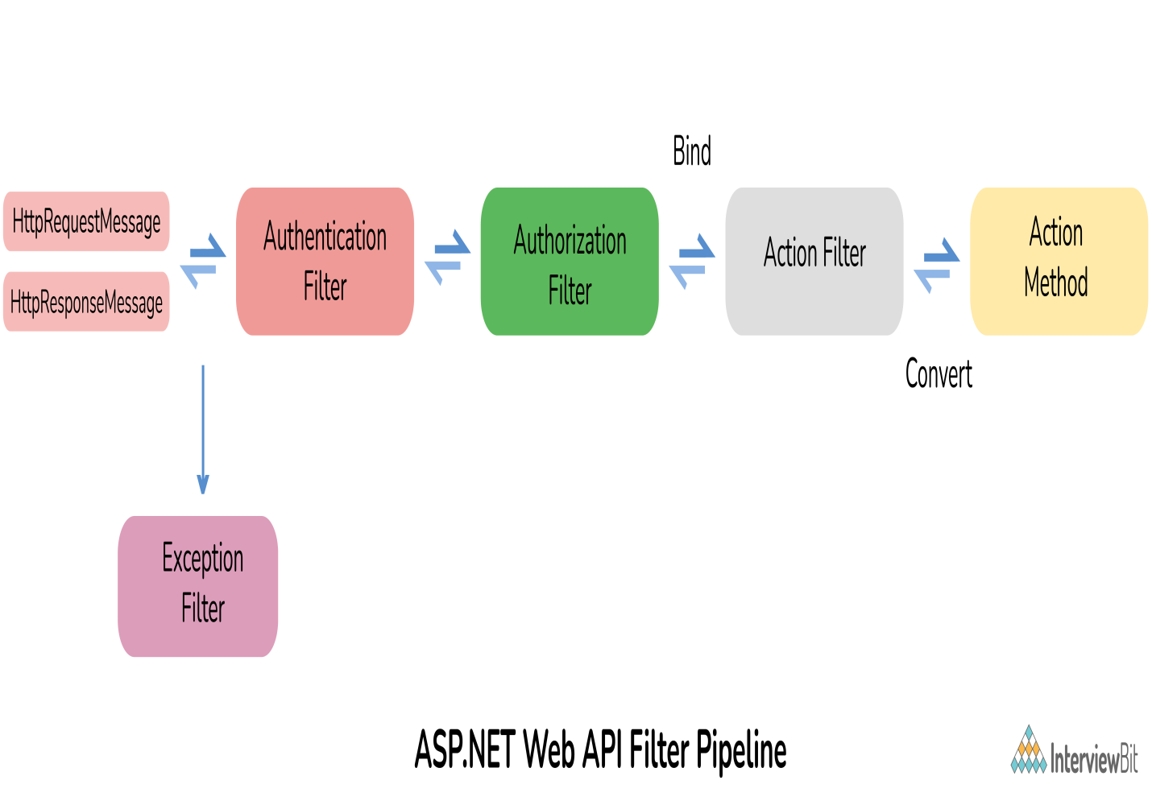

**What is ASP.NET Web API routing?**

Routing is the most important part of ASP.NET Web API. Routing is a way how Web API matches a URI to an action. It is basically a process that decides which action and controller should be called. The controller is basically a class that handles all HTTP requests. All public methods of controllers are basically known as action methods or just actions. Whenever a Web API framework receives any type of request, it routes that request to action.

There are basically two ways to implement routing in Web API as given below:

**Convention-based routing**:

Web API supports convention-based routing. In this type of routing, Web API uses route templates to select which controller and action method to execute.   
  
**Attribute-based routing**: Web API 2 generally supports a new type of routing known as attribute routing. As the name suggests, it uses attributes to define routes. It is the ability to add routes to the route table via attributes.

### How to unit test Web API?

Using Web API tools like Fiddler, we can perform unit testing in Web API. Fiddler is basically a free debugging proxy for any browser that can be used to compose and execute various HTTP requests to Web API and check HTTP response. It is simply used for testing restful web services. It allows one to inspect and check both incoming and outgoing data to monitor and modify requests and responses before the browser receives them.  Below is given some setting that is needed to be done fiddler:  
  
Fiddler – Compose Tab -> Enter Request Headers -> Enter Request Body and then execute

